Press Release Thursday 11 May 2017
New mental health program teaches students how to stress less
Students in years 11 and 12 will be shown how to develop tools to manage stress and anxiety with the launch today of a new program by award-winning mental illness educators, Mental Illness Education ACT (MIEACT).
The Stress Better program is designed for ACT and NSW students in years 11 and 12 to help them recognise the differences between worry, stress and anxiety, and how best to alleviate symptoms to ensure their mental well-being.
The program offers direct positive contact with volunteers within the community who have personal experience with mental illness.
Mission Australia reports young adults nominate stress to be their top issue of concern. Studies have shown direct contact (experienced volunteer presentations) to be one of the best ways to reduce the stigma that becomes one of the biggest barriers to young people seeking help for mental ill health.
Snow Foundation is sponsoring the program, which has been developed in collaboration with Lifeline ACT.
“Programs that empower people to cope through life’s challenges, to exercise self-care and to help others, should be common place in schools,” Lifeline ACT Chief Executive Officer Carrie Leeson said.
“Learning these skills from a young age strengthens families and communities, this program is fantastic.”
MIEACT Executive Officer Samantha Davidson-Fuller said the program has been developed over a number of years and aims to help young adults from all backgrounds, including those who are vulnerable and most at risk of developing a mental illness related to stress or anxiety.
“The program gives young people life tools to deal with stress and anxiety and expands on MIEACT’s program of direct positive contact through personal storytelling,” Ms Davidson-Fuller said.
“MIEACT has worked with the ACT Health Directorate to ensure this program supports young people who may be experiencing anxiety and stress from life situations that are outside their locus of control,” she said.
“MIEACT’s Stress Better program aims to help young adults aged between 16 and 25 years to better manage stress and anxiety by inspiring them to value their community, friends, family, hopes and aspirations, while also providing practical tools to alleviate stress and anxiety.”
Statistics from the Mission Australia Youth Survey 2016 reveal the top three areas young people are most concerned about are coping with stress, school and body image. Of those surveyed, 44.4 per cent were “highly concerned” about coping with stress, 37.8 per cent were “highly concerned” about school and 30.6 per cent were “highly concerned” about body image (see attached graph).
The percentage of young people t
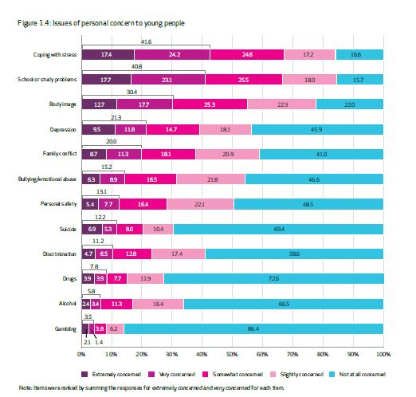
Mission Australia Youth Survey 2014

Invited guests for Thursday’s launch include representatives from:
- Snow Foundation,
- Richmond Fellowship of the ACT,
- Canberra Education & Training Directorate,
- ACT Health Directorate,
- Parents & Citizens Association of the ACT, Queanbeyan, Goulburn & Yass,
- High schools and colleges from ACT and regional NSW,
- Menslink,
- University of Canberra,
- Mental Health Community Coalition of the ACT,
- Youth Coalition of the ACT,
- Youth Coalition Youth Media Team,
- MIEACT Volunteer Educators

MIEACT has partnered with The Richmond Fellowship of the ACT to deliver the new program into the NSW region.
MIEACT is a not-for-profit organisation based in the ACT that delivers mental health workshops that promote the personal stories of volunteers with lived experiences of mental illness to educate the community, reduce stigma and discrimination, and to encourage positive health choices.
Programs are delivered within schools, community groups, government workplaces and the corporate sector, and include PTSD Awareness, GP and Allied Health training, Positive Body Image, Community Education, Workplace Mental Health and Training, Short Film and Radio, and now Stress Better.

Launch Starts: 4.30pm for 5pm
Where: Legislative Assembly Reception Room
Media Access: 4.15-5pm for photos & interviews with
- Mental Health Australia CEO Frank Quinlan (MC)
- MIEACT Executive Officer Samantha Davidson-Fuller
- Mental Health Community Coalition ACT Executive Officer Simon Viereck
- MIEACT Volunteer Educator Emma Manderson (personal storyteller)
- Snow Foundation CEO & Director Georgina Byron (program supporters)

Media contact: Kathy Brine 0408 27 6606 or phone 6257 1195

