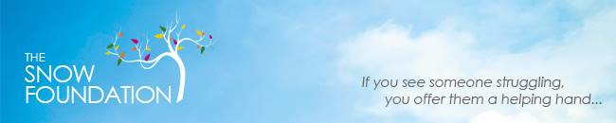
23 March 2017
LIFECIRCLE FILMS FOCUS ON LIVING WITH THE DYING
The launch today of a series of films featuring carers of the dying heard that 70% of Australians wanted to die at home, but only 15% nationally have had their wish fulfilled.
Supported by the Snow Foundation, Calvary Hospital and Clare Holland House in Canberra, ‘Conversations’ was produced by LifeCircle, and features Canberra residents sharing their perspective and stories around caring for someone who is dying.
The CEO of LifeCircle, Melissa Reader, said the organisation’s focus was to profoundly change the experience of death and dying.
“We want to build the personal capacity of carers at a time when they are confronted with a tumultuous field of emotion”, Ms Reader said.
“The role of the carer is critical, but there is a fragmented and complex system of assistance for carers. We need to support those carers, build a circle of care around them, and help them to access available services”.
Ms Reader said the number of Australians dying would double in the next 25 years, and many people were not dying they way they wanted to.
Speaking at the launch, Rachel Bilton-Simek, Palliative Education Coordinator,
at Canberra’s Calvary Hospital, said “it is widely accepted that in order for communities to grow and have the capacity to nurture, especially those who are challenged by life limiting illness, we need to talk openly about our mortality and the issues we face when we are dealing with our death, or the death of a loved one”.
“Videos, films and other creative arts allow us to explore these topics tenderly and with heart, and I welcome any means that brings us together and allows for compassionate and necessary conversations to flow freely”.
“Conversations” can be viewed at: http://lifecircle.org.au/#conversations

For more information, contact:
Niree Creed, Media Adviser, Snow Foundation: 0418625595
Melissa Reader, CEO, LifeCircle: 0410546 894

